Alternative wiring guide (Pico w)

To wire the pico to the switches in a way that works we will need to create a key matrix. Which is columns of wire that intersect and at key press they will scan over both horizontal and vertical axis to find which switch did the pressing. This is a far more efficient method of wiring than wiring each key individually. I will show an image of what it would look like on a 3x3 macroboard

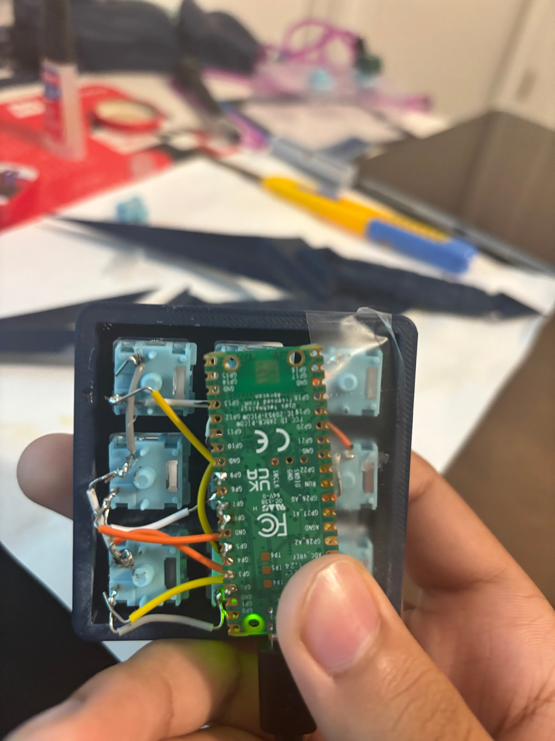

To be fair this isn't the best representation of a key matrix but in the back can you see the rows soldered vertically and horizontally.

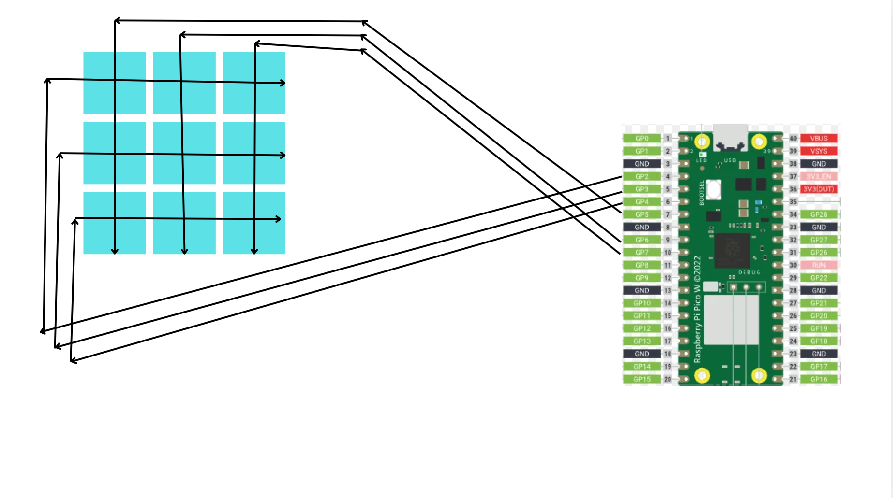

This is a better diagram of the same image where gpio pins on the pico are wired out in rows horizontally and vertically.
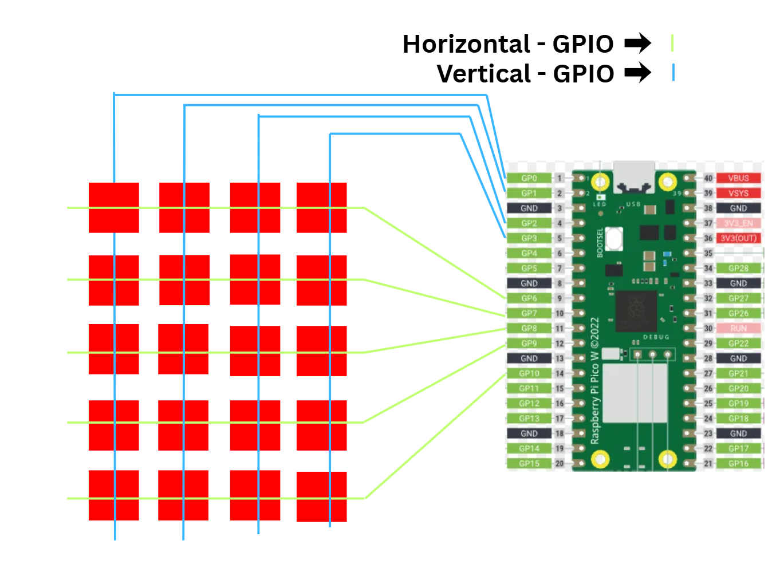
This is a better representation of how your matrix may look like. Remember to solder 1 end of the wire to 1 part of the switch and and the other end to the other part.

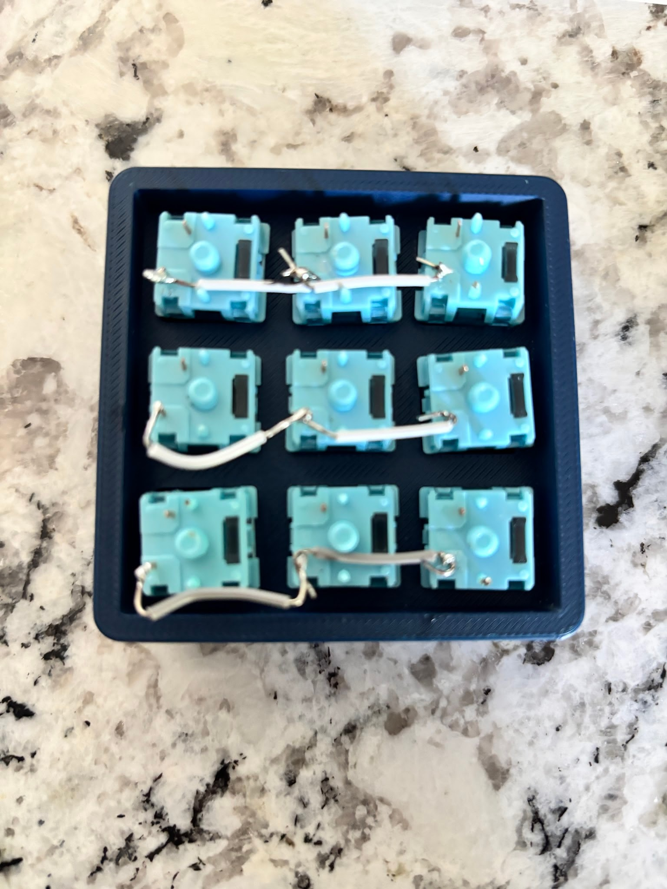

Notice how the wires are soldered to the metal pins on the switches and the next wires. This helps flow the current through each of them.

This is a guide on how a key matrix works on a deeper level than what I explained
https://docs.qmk.fm/how_a_matrix_works

This was my original code for each key on the 3x3 keyboard. It's coded so that each key pressed is a letter instead of a macropad.
import board
import digitalio
import time
import usb_hid

from adafruit_hid.keyboard import Keyboard
from adafruit_hid.keycode import Keycode

keyboard = Keyboard(usb_hid.devices)

rows = [
digitalio.DigitalInOut(board.GP2),
digitalio.DigitalInOut(board.GP5),
digitalio.DigitalInOut(board.GP9)
]

cols = [
digitalio.DigitalInOut(board.GP3),
digitalio.DigitalInOut(board.GP7),
digitalio.DigitalInOut(board.GP6)
]

for row in rows:
row.direction = digitalio.Direction.OUTPUT
row.value = True

for col in cols:
col.direction = digitalio.Direction.INPUT
col.pull = digitalio.Pull.UP

keymap = [
[URL 1, URL 2, URL 3],
[URL 4 , URL 5, URL 6],
[URL 7, URL 8, URL 9]
]

pressed = [[False for _ in range(3)] for _ in range(3)]

while True:
for r in range(3):
for row in rows:
row.value = True

rows[r].value = False

for c in range(3):
is_pressed = not cols[c].value

if is_pressed and not pressed[r][c]:
keyboard.press(keymap[r][c])
keyboard.release_all()
pressed[r][c] = True

elif not is_pressed:
pressed[r][c] = False

time.sleep(0.01)

I have put areas where to place the urls for say if you wanted to open a website when pressing a key.

